Introduction To Computer Networks

* Mother Boards
* Ram Modules
* Daughter Cards
* Bus Slots
* SMPS
* Internal Storage Devices
* Interface ports

Mother Boards

The motherboards serves as a single platform to connect all of the parts of a computer togeather.It can be considered as the backbone of the computer.It connects the CPU,Memory, Hard drive,Optical drive , Video card, Sound card and other parts.It also connects Expansion cards directly or via cables.

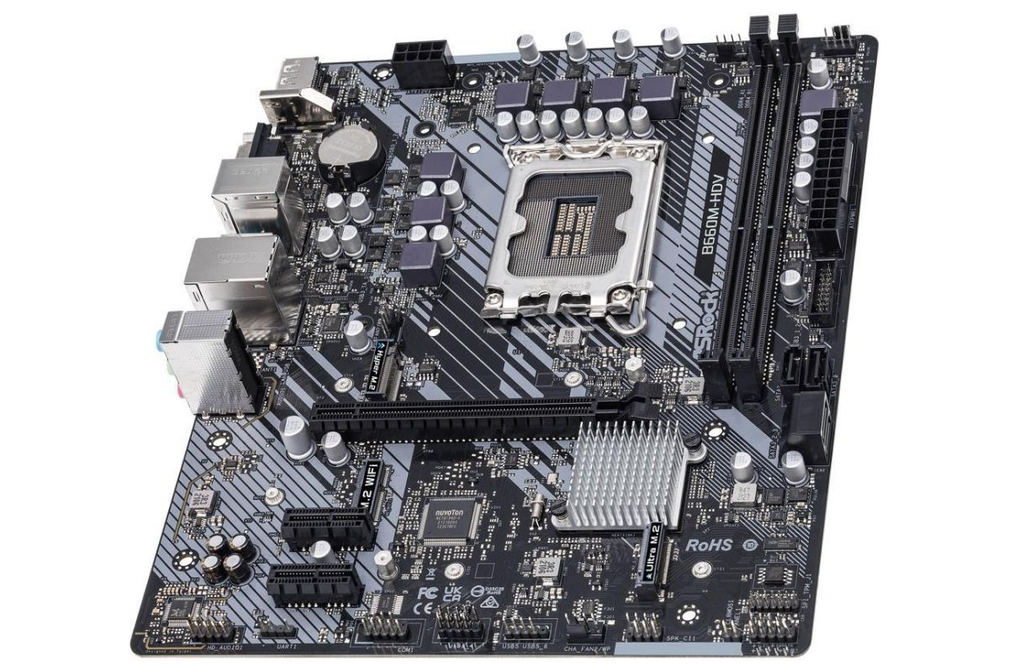

Types of Mother Boards

* Standard ATX
* Micro ATX
* eXtendend ATX

Standard ATX –

This motherboard comes in 305\*244mm (length\*breadth) dimension, these dimensions can vary with different manufactures.This motherboard offers more expansion slots,up to four slots for Ram,Two or sometimes more than two PCIe slots for dual graphics cards and more USB and other ports for connectivity,also its size gives space between components for airflow to keep heat in control. This size of motherboard is used by those who want more expansion slots and difference connecting ports and deal with heavy workloads. This motherboards will only fit in cases which support full ATX or Extended ATX motherboards.

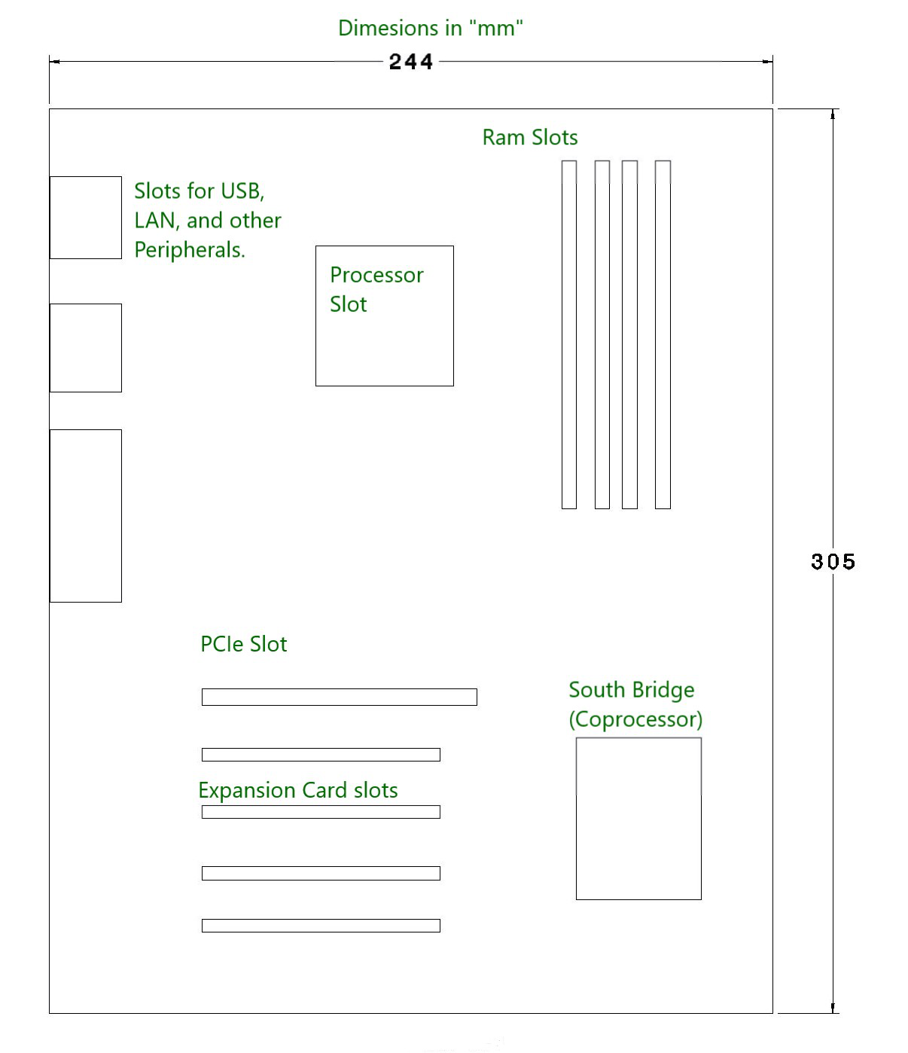

Micro ATX

This motherboards come in 244\*244 mm (length\*breadth) dimension(these dimension can vary with different manufactures.).This Motherboard has less ports and slots as compared to Standard ATX board.This type of motherboard is more suitable for thoses who don’t want to much connectivity and later upgrades like adding more than ram and additional GPU or Graphics card and adding PCI cards.This board can fit any case which has enough room 244\*244 mm of space and can also be fit in bigger cases which accept Standard ATX and Extended ATX motherboards.

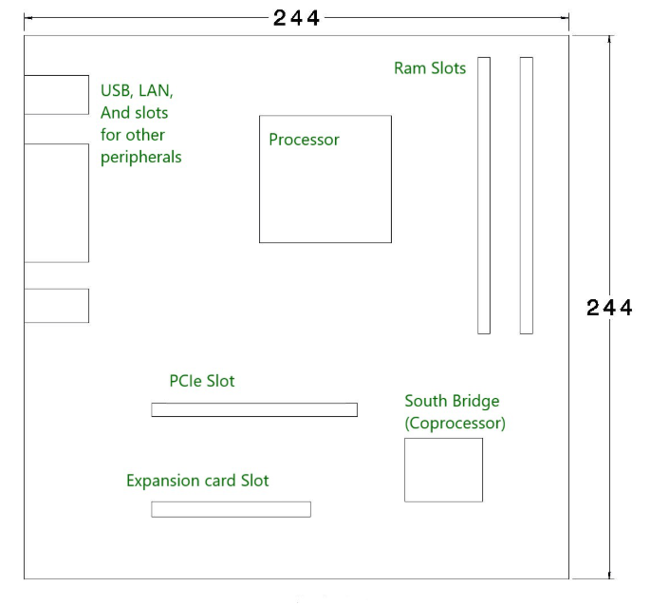

eXtenend ATX

This motherboard is 344\*330 mm dimensions (these dimensions can vary with different manufacturer). This motherboard is designed for both dual CPU and single configuration and has up to 8 ram slots and has more PCIe and PCI slots for adding PCI cards for different purposes. It is used for workstations and servers. Some EATX motherboards are also designed for desktop computing, and there is ample space for cooling and attaching peripherals.

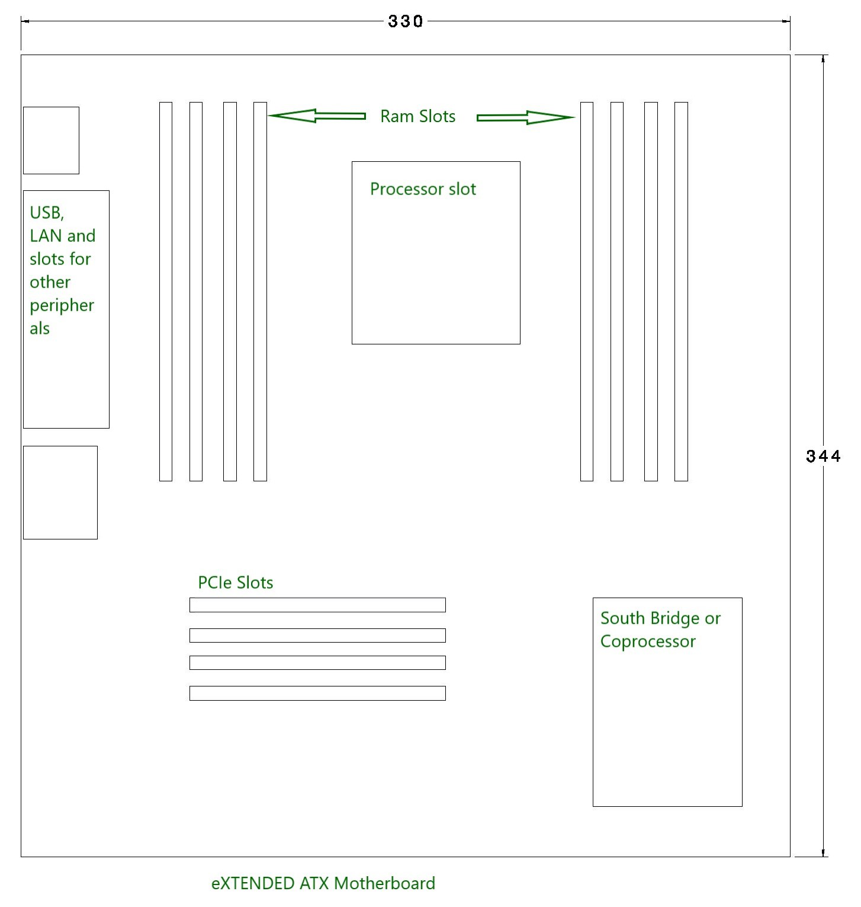

Ram Modules

Random Access Memory (RAM) is used to store the programs and data being used by the CPU in real-time. The data on the random access memory can be read, written, and erased any number of times. RAM is a hardware element where the data being currently used is stored. It is a volatile memory.

Types of RAM:

Static RAM, or (SRAM) which stores a bit of data using the state of a six transistor memory cell.

Dynamic RAM, or (DRAM) which stores a bit data using a pair of transistor and capacitor which constitute a DRAM memory cell.

Read Only Memory (ROM) is a type of memory where the data has been prerecorded. Data stored in ROM is retained even after the computer is turned off ie, non-volatile. Types of ROM:

Programmable ROM, where the data is written after the memory chip has been created. It is non-volatile.Erasable Programmable ROM, where the data on this non-volatile memory chip can be erased by exposing it to high-intensity UV light.Electrically Erasable Programmable ROM, where the data on this non-volatile memory chip can be electrically erased using field electron emission.Mask ROM, in which the data is written during the manufacturing of the memory chip.

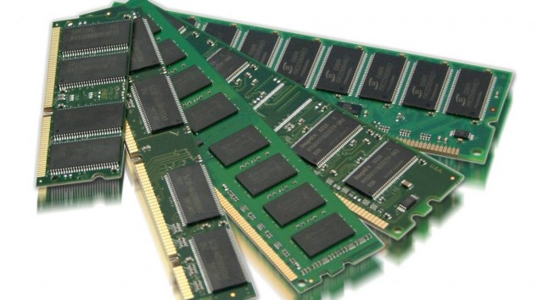

Daughter Cards

A daughterboard is connected directly to the motherboard. Unlike expansion cards, which connect with the motherboard using bus and other serial interfaces, daughterboards are usually directly embedded through soldering. Like a motherboard, a daughterboard has sockets, pins, plugs and connectors to be attached to other boards. Typically, daughterboards are released as a post-launch update to a motherboard or expansion card. For example, a MIDI daughterboard is used to add on the functionality of the sound card.

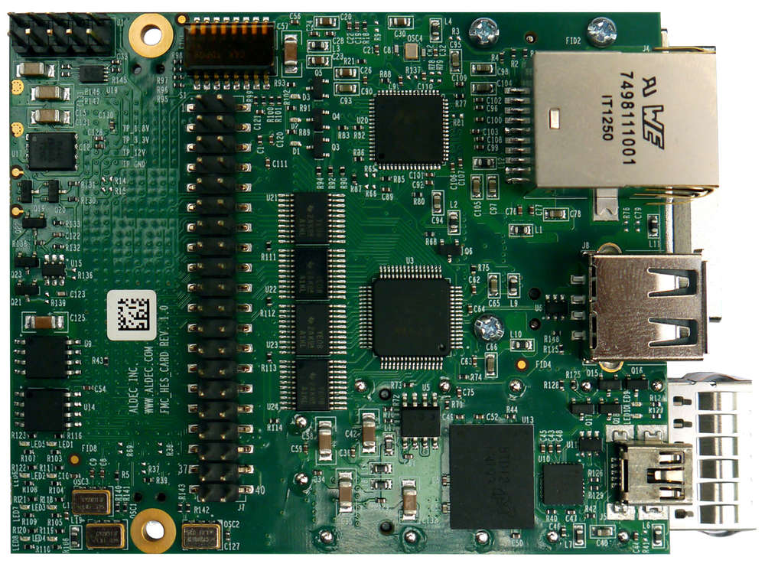

Bus Slots

An expansion slot is a socket on the motherboard that is used to insert an expansion card (or circuit board), which provides additional features to a computer such as video, sound, advanced graphics, Ethernet or memory.The expansion card has an edge connector that fits precisely into the expansion slot as well as a row of contacts that is designed to establish an electrical connection between the motherboard and the electronics on the card, which are mostly integrated circuits. Depending on the form factor of the case and motherboard, a computer system generally can have anywhere from one to seven expansion slots. With a backplane system, up to 19 expansion cards can be installed.

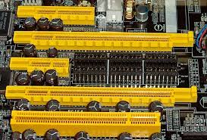

SMPS (SWITCHED MODE POWER SUPPLY)

A switched-mode power supply (SMPS) is an electronic circuit that converts power using switching devices that are turned on and off at high frequencies, and storage components such as inductors or capacitors to supply power when the switching device is in its non-conduction state Switching power supplies have high efficiency and are widely used in a variety of electronic equipment, including computers and other sensitive equipment requiring stable and efficient power supply.A switched-mode power supply is also known as a switch-mode power supply or switching-mode power supply

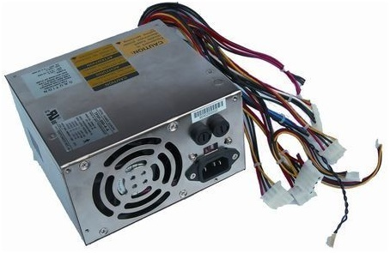

Internal Storage Devices

Most computers have some form of internal storage. The most common type of internal storage is the hard disk.At the most basic level, internal storage is needed to hold the operating system so that the computer is able to access the input and output devices.it will also be used to store the applications software that you use and more than likely, the original copies of your data files.Internal storage allows the data and applications to be loaded very rapidly into memory, ready for use. The data can be accessed much faster than data which is stored on an external storage device. This is because internal storage devices are connected directly to the motherboard and its data bus whereas external devices are connected through a hardware interface such as USB, which means they are considerably slower to access.

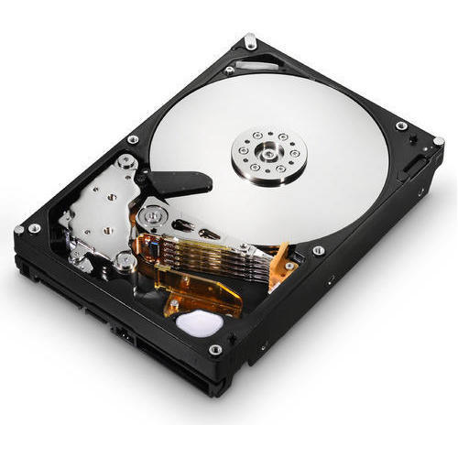

Interface ports

In computer hardware, a port serves as an interface between the computer and other computers or peripheral devices. In computer terms, a port generally refers to the part of a computing device available for connection to peripherals such as input and output devices. Computer ports have many uses, to connect a monitor, webcam, speakers, or other peripheral devices. On the physical layer, a computer port is a specialized outlet on a piece of equipment to which a plug or cable connects. Electronically, the several conductors where the port and cable contacts connect, provide a method to transfer signals between devices.Bent pins are easier to replace on a cable than on a connector attached to a computer, so it was common to use connectors for the fixed side of an interface.

